Window Lifter
Window Lifter Module Design

History
Issue status  (Index) | Maturity/Date  (draft/invalid/valid)  (dd-mmm-yyyy) | Author  AEP CES | Check/Release  AEP CES | Description
1.0 | Draft  22-june-15 | Alexis Garcia | Alexis Garcia | Creation of the document
2.0 | 25-june-15 | Alexis Garcia | Alexis Garcia | Some corrections of the document and adding of multiple flow charts
3.0 | 24-july-15 | Alexis Garcia | Jose Roberto | Modification according to the new design with scheduler integration and State Machine design

Table of Contents
1 Purpose 3
2 Definitions and abbreviations 3
3 Realization constraints and targets 3
4 SW Conceptual design 3
5 SW Component internal breakdown 4
5.1 Functional Decomposition 4

Purpose
The purpose of this document is to specify the function of the module of the window lifter and the relation between his components. This includes the function of UP and DOWN with two modes of functionality , the automatic mode and the manual mode, also a validation of the button press and a pinch function for the safety of the user and prevention of accidents.

Definitions and abbreviations
Definitions
PIT | Process interrupt timer
GPIO | General Purpose Input Output
STM | System Timer Module
MCcore | Microcontroller core
one touch | Function for the automatic mode
Anti pinch  MAL  HAL  APP | Feature that prevents accidents while the window goes up  Micro Controller Abstraction Layer  Hardware Abstraction Layer  Application Layer

Abbreviations
References
N° | Document name | Reference
1 | Window Lifter Requirements
2 | Traceability Matrix WL Module

Realization constraints and targets

The main purpose of this module is to provide the capability to the final user to be able to control the movement of the window in up and down direction; also this module provides a function of anti pinch, which downs the window in case of emergency of a possible accident. For a valid button press, it must last at least 10 ms, the auto mode is active if the press last for less than 500 otherwise the manual function is active while the button is press, the transition between each step of the window is 400 ms. The anti pinch feature it can only be activated in the up movement, downs totally the window and blocks the buttons for 5 seconds.

SW Conceptual design
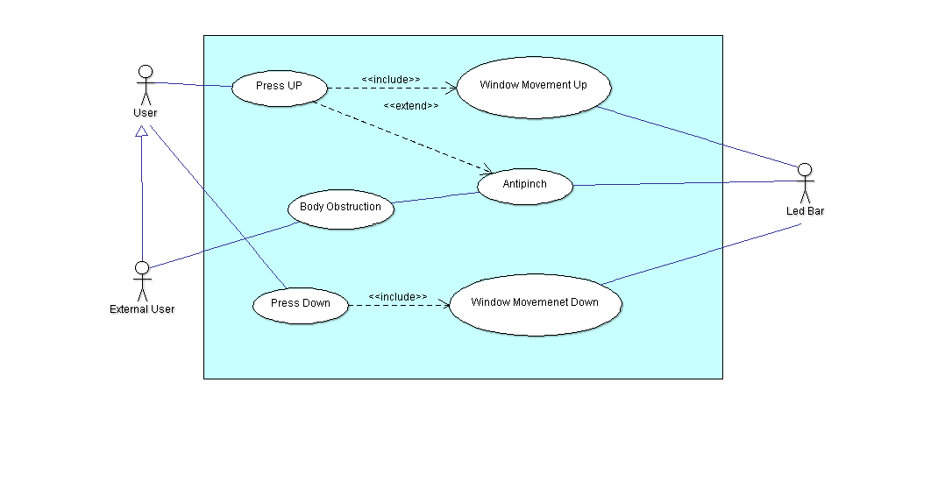
Figure 1 Use Cases Diagram

User. The user is the person that will interact with the buttons, the final user of the application.
External user. The purpose of this actor is to represent a possible obstruction in the window; it can be the same user or also another external object or person.
Press Up. This represents the case when the user press the up button, in this instance the window shall go Up in two possible mode, automatic and manual, also the blue led indicator will go on, represented in the case Window Movement Up.
Press Down. This case represents when the user press the down button , in this case the window shall go Down in two modes, the automatic mode and the manual mode, also the green led indicator will go on, this represents the include case Window Movement Down.
Body Obstruction. This represents the case when an external user provokes an obstruction during the up movement in both modes, this will lead to the use case of Anti pinch where the window shall stop moving and going totally open, after that the button functions will be blocked for 5 seconds.
Led bar. This actor represents the led bar that will interact with the functions, in this case this will emulate the movement in both direction of the window.

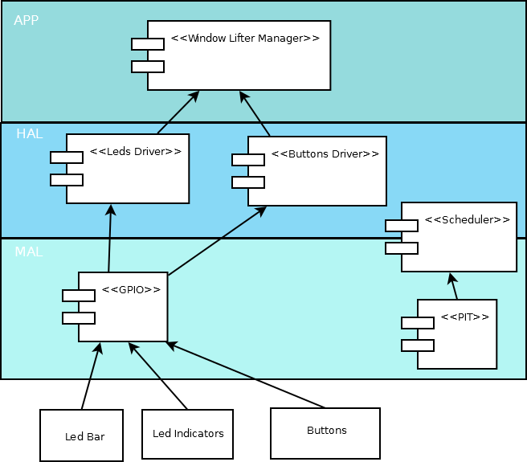
Figure 2 Components Diagram for the Window Lifter

The approach for this module is modeled based on the diagram above, in this it is implemented a layer based modeling, and each layer represents an interaction in different levels.
MAL layer. This layer is composed by the basic interaction that controls the registers in the microcontroller, in this case we use the GPIO and PIT for input / output control and timer controlling of the scheduler.
HAL layer. This layer is composed by the interaction between the registers and the main application; in this layer we have two drivers, one that controls the led bar and led indicator and another one that controls the button press time and the command request.
APP Layer. This layer is composed in a nutshell for the functionality requested, in this case we have the code for window lifter module that controls and handles the inputs of the buttons and converts it into motion.
Finally we have three physical components that are the Led Bar, The led direction Indicators and the buttons for the system.
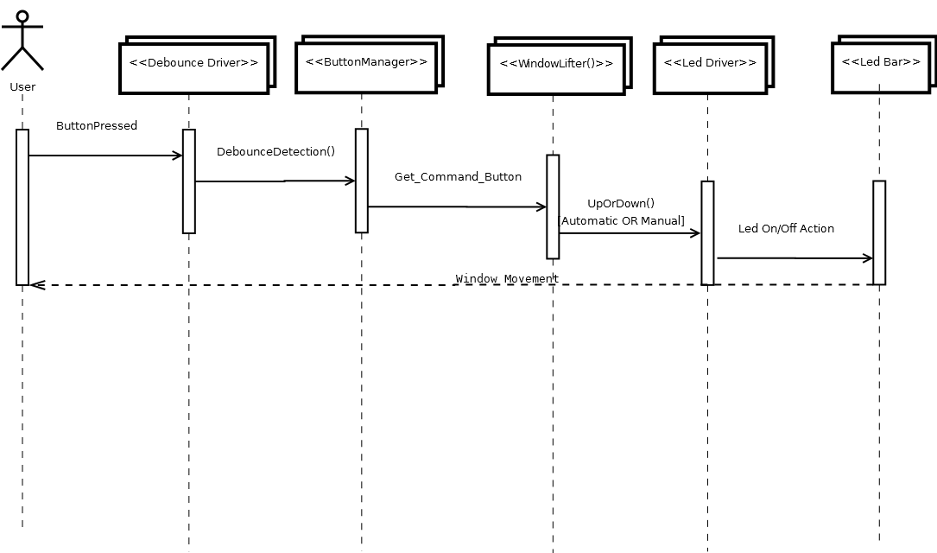
Figure 3 Sequence Diagram

Buttons Pressed is the message sent to the buttons by the user, represents when the user press a button, up or down in the system. The system detects a valid button push via the de bounce driver, after this, the driver sent a message for a valid button when is a valid press time (10ms) to the driver for button management, this filters the command for the button press and sent this to the module application of the window lifter, then the window lifter handles this command in a specific state and determines the direction of movement and sent the information to the led driver, finally this sent the order to turn on or turn off the leds to the led bar and this impacts on the user viewing the movement reflect.

SW Component internal breakdown
For this module it has been implemented a scheduler to provide a design approach for the periodic call of task, making easier to maintain.
The specifications of the scheduler task and Tick for the OS are the next.
The scheduler uses a no Preemptive rate monotonic schema for the algorithm of scheduling.
The OS Tick is set to 500 microseconds.
The pit channel target frequency is set to 1600.
With these two configurations the tasks times are 1.125 milliseconds, 2.5 milliseconds, 5 milliseconds, 10 milliseconds, 20 milliseconds and 40 milliseconds.
For the valid input purpose it is used the 1.125ms task for the de bounce function, the 10 ms is used to check the button commands inputs and finally the State machine for the window lifter app is running under the 40 ms task.

Functional Decomposition
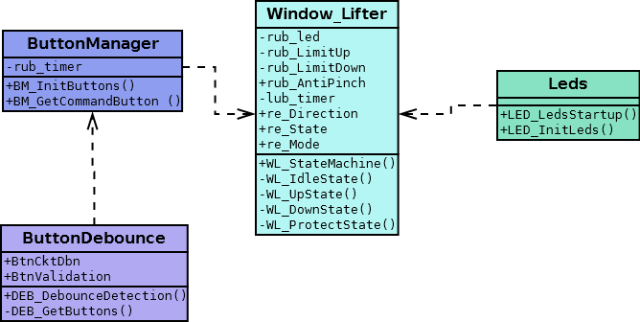
Figure 4 Diagram Class window lifter
Function Description and Dynamic Behavior

Function void WL_StateMachine (void)
Description | This function provides the main control of the state machine for the window lifter application, it is called in one task of the scheduler (40 ms), and this provides the flow of states and calls his respective functions.
Parameter 1  <input| output| input> | N/A
Return Value | Void
Precondition | This function depends on a lower task call (button Manager) that provides the flow of the states
Post condition | N/A
Error Conditions | Default state = idle

Function void WL_ProtectState (void)
Description | This function provides the actions to be taken in a protect state, mainly it starts a timer and sets the direction in immobile, during this time the button read are blocked and when the timer expires (5 seconds) its resets some variables and changes the state to idle.
Parameter 1  <input| output| input> | N/A
Return Value | Void
Precondition | This function is called only when the window goes up and the antipinch feature is activated
Post condition | N/A
Error Conditions | N/A
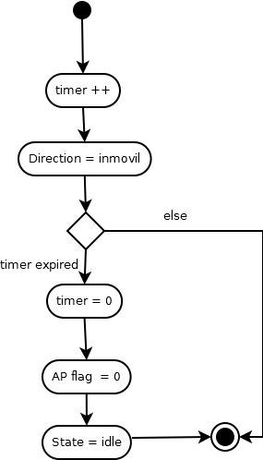
Figure 4.1 protect state activity diagram

Function void WL_DownState (void)
Description | This function provides the action to achieve the window movement in down direction, first checks for a release in down button or the down limit, if not the case checks a timer for 400 ms transitions, after this turns off the actual led and changes the led level.
Parameter 1  <input| output| input> | N/A
Return Value | Void
Precondition | This function is called when the down button is pressed and during the pressing or auto mode in down State
Post condition | Checks for the Anti pinch activation to send the state into protect
Error Conditions | N/A

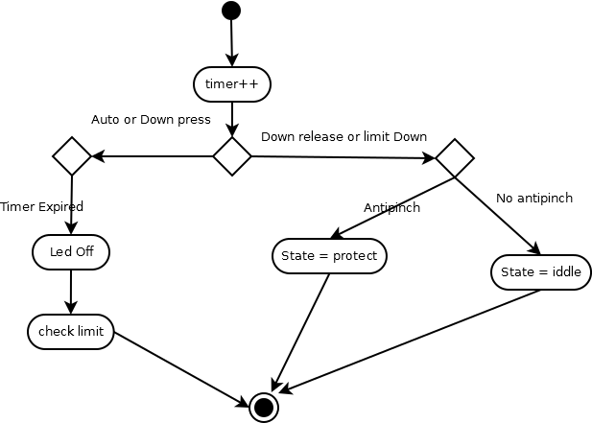
Figure 4.2 down state activity diagram

Function void WL_UpState (void)
Description | This function provides the action to achieve the window movement in up direction, first checks for a release in up button or the up limit, if not the case checks a timer for 400 ms transitions, after this checks for the anti pinch flag, if it’s off turns off the actual led and changes the led level., otherwise sets the mode of function and state into down.
Parameter 1  <input| output| input> | N/A
Return Value | Void
Precondition | This function is called when the down up is pressed and during the pressing or auto mode in up State
Post condition | N/A
Error Conditions | N/A

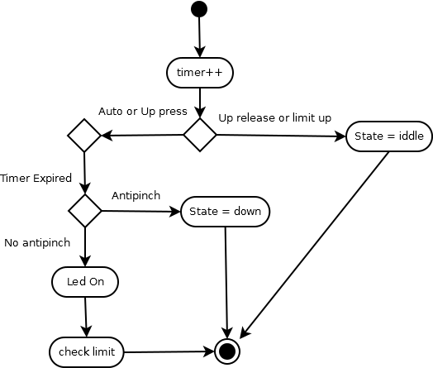
Figure 4.3 up state activity diagram

Function void WL_IdleState (void)
Description | This function is the default state and initial state, handles the commands coming from the button manager and according to these commands, sets the state into his according up direction in up state, down direction in down state, otherwise it means it’s not moving (immobile) and sets the state in self (idle)
Parameter 1  <input| output| input> | N/A
Return Value | Void
Precondition | This function is the default and initial state in the state machine for the window lifter
Post condition | N/A
Error Conditions | N/A

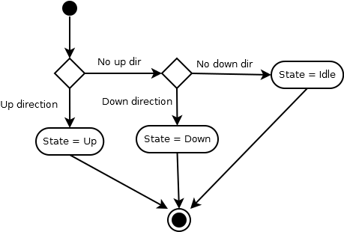
Figure 4.4 idle state activity diagram

Dynamic Behavior
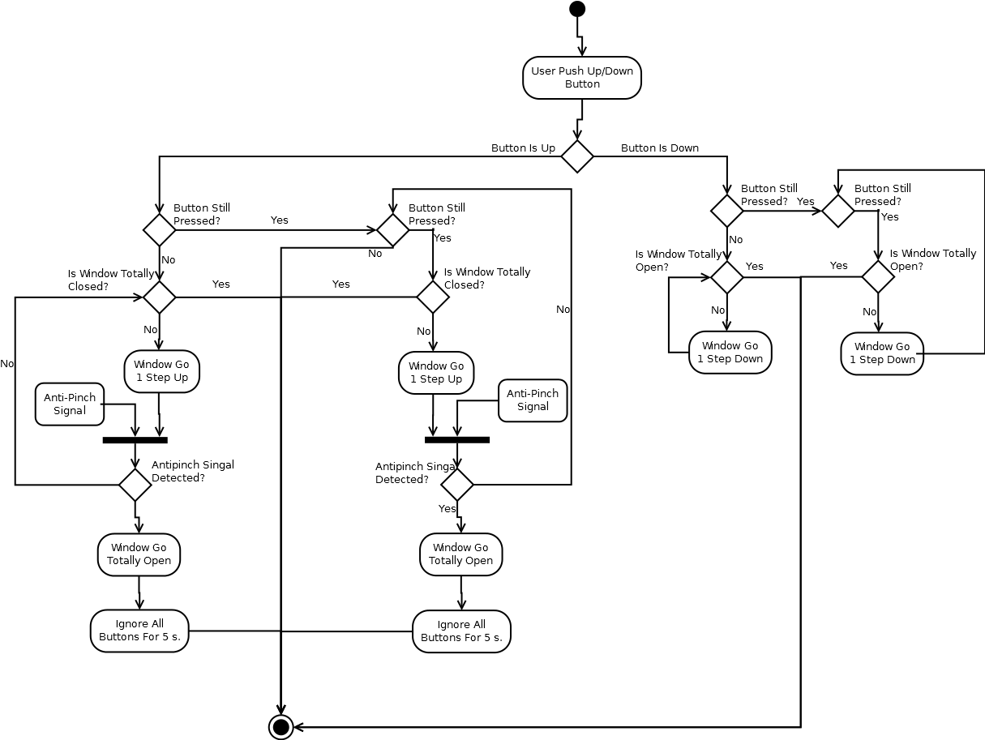
Figure 5 Activity Diagram of the general module

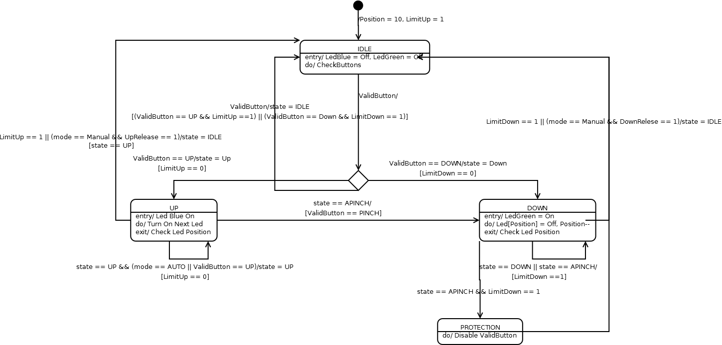
Figure 6 States Diagram

IDLE state: Checks for the command in the actual time, this has two transitions, depending on the command and direction changes the states for Up or Down, also this state resets some variables and sets the direction to immobile.
UP state: Checks for the status of the up button and the mode of function, if its auto mode or its still pressed the leds will turn on, otherwise if the button is released or the limit up is reached the state is changed to IDLE. Also this function checks for the Anti pinch flag, if it’s active during the up movement; it will change the state to DOWN and sets the mode in auto.
DOWN state: Checks for the status of the down button and the mode of function, if its auto or its still pressed the leds will turn off, otherwise if the button is released or the limit down is reached the state is changed to IDLE. Also this function checks if the anti pinch is active, in this case the state is set in Protect.
Protect state: During this state a timer starts and the direction is set to immobile, during 5 seconds the button detection is disabled, after the timer its expired the anti pinch is reset and , the timer resets and the state its set to IDLE.
There is a default state for security where the state is set to IDLE.

